ROCKS
Rocks are the solid materials which forms part of the surface of the earth and other smaller planets. Rocks are made up of an aggregate of minerals. The mineral composition of rocks includes gold, diamond, iron and micas. Rocks are large masses of stone which form the vital of the earth’s crust.
TYPES OF ROCKS
Based on their mode function, we have mainly three (3) types of rocks namely; igneous rocks, sedimentary rocks and metamorphic rocks.
- IGENOUS ROCKS; these are formed from molten magma(lava) which comes out during volcanic eruption. The magma cools and solidifies. When it cools and solidifies inside the earth, it forms intrusive rocks. Magma that has cooled on the surface of the earth is known as extrusive rocks. Eg granite, gabbro, diorite, basalt, quartz.
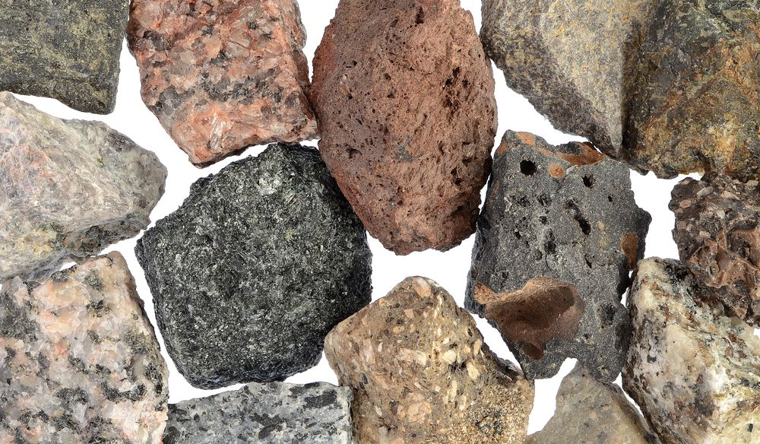
CHARACTERISTICS OF IGENOUS ROCKS.
- They are not stratified (i.e they are not in layers).
- They are crystalline in structure, that is they contain crystals.
- They do not contain fossils.
- They are usually heavy, hard and shiny.
- They are generally resistance to erosion.
- Igneous rocks are mainly of primary minerals.
- They are dark in colour.

- SEDIMENTARY ROCKS; are rocks formed from the deposition and cementation of sediments of organic and inorganic materials. The sediments are other weathered rocks and organic materials such as bones of animals and plants. They are accumulated in layers, one on top of the other. After a period of time they become hardened and cemented together. Eg sandstone, limestone, shale, clay, breccia, conglomerate.
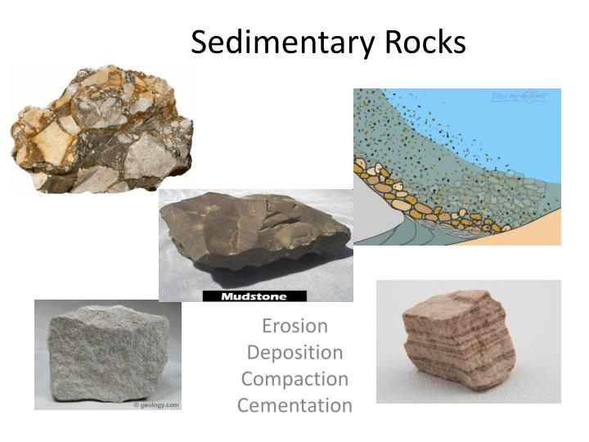
CHARACTERISTICS OF SEDIMENTARY ROCKS.
- They are stratified.
- Contain organic matter or fossils.
- They non-crystalline in structure.
- They relatively soft.
- They are not resistance to erosion or weathering because of lines of weakness between strata.

The table below shows some examples of sedimentary rocks and their composition.
Sedimentary rock | Major composition
Limestone | Sediments of calcite
Shale | Mud and slit compacted
Sandstone | Sediments of granite
Conglomerate | Pebbles cemented together

NB;
- Calcareous rocks; when sedimentary rocks are formed from remains of corals/fish shells, such rocks are called calcareous rocks. Eg limestone and chalk.
- Carbonaceous rocks; when sedimentary rocks are formed from the remains of plants such as swamps, forest eg coal, petroleum, lignite.

- Metamorphic rocks; are formed from rocks which have been subjected to high temperature and pressure. Thus, they either igneous/sedimentary rocks that have changed in form
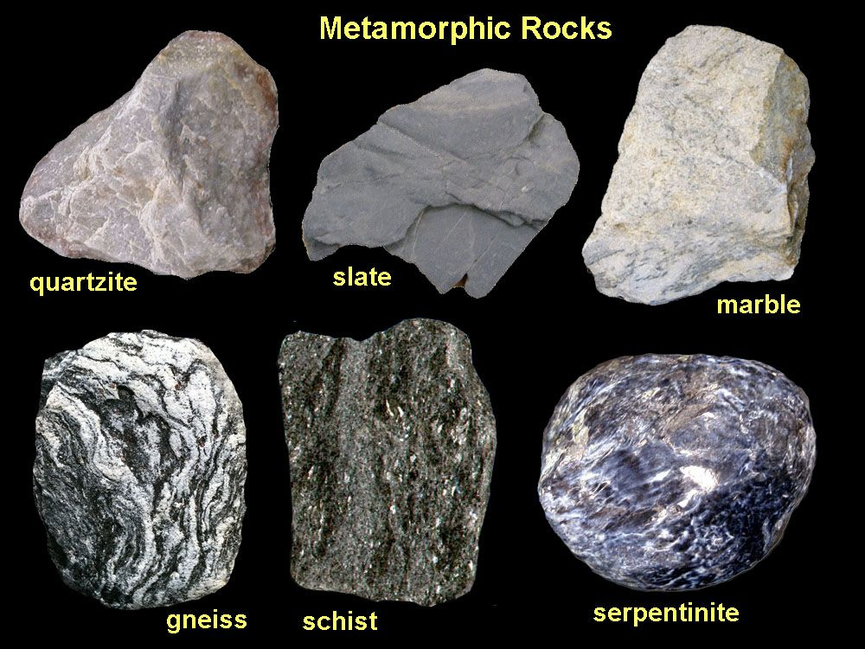
The table below shows some examples of metamorphic rocks and their composition.
Original rock | Types of rocks | Metamorphic rocks
Clay | Sedimentary | Shale
Limestone | Sedimentary | Marble
Sandstone | Sedimentary | Quartzite
Granite | Igneous | Gneiss
Shale | Sedimentary | Schist
Gabbro | Igneous | Serpentine
Coal | Sedimentary | Graphite

CHARACTERISTICS OF METAMORPHIC ROCKS.
- They are usually dull and tough in appearance.
- They are hard and massive.
- They contain both primary and secondary minerals.
- They are rarely having fossils.
- They exist in different colours and texture.
WEATHERING OF ROCKS
Weathering is the process by which rocks are broken down into smaller rock particles. There are three main types of weathering namely; physical weathering, biological and chemical weathering.
- Physical weathering; this type of weathering results in the mechanical breakdown of rocks into smaller particles. There is no change in the chemical composition on the rock minerals.
FACTORS OF PHYSICAL WEATHERING.
- Changes in temperature
- Rainfall/ water
- Movement of ice mass over rocks
- Strong winds blowing objects against rocks.
- Expansion of frozen water in rocks.

- Biological weathering; this type of weathering involves the breakdown of rocks into smaller particles by the activities of animals (including human), plants and some micro-organisms.
FACTORS OF BIOLOGICAL WEATHERING
- Human activities such as mining, farming, building and road construction.
- Stress from growing roots of plants through cracks and crevices.
- Burrowing action and feeding habits of animals.
- Some plants also produce organic acid which dissolves rocks minerals and contribute to their breakdown.
Chemical weathering; this is type of weathering is due to the chemical reaction of minerals in rocks and the action of atmospheric gases (CO₂ and O₂). The chemical composition the rock mineral is altered.

FACTORS OF CHMICAL WEATHERING
- Hydrolysis; this is the disintegration of minerals in rocks on reacting with water. This produces excess OH⁻ and OH⁺ ions. The OH⁻ and OH⁺ ions dissolve the rocks minerals and cause its break down.
- Hydration; this involves the rigid attachment substances especially rock minerals making them soft and porous for easy breakdown.
- Oxidation; this is the combination of atmospheric oxygen and oxygen contained in rain water with rock mineral or compound. This result into a less stable structure of rocks. Oxidation is the major process through which chemical weathering occurs.
- Carbonation; this refers to reaction between inorganic carbonic acid in soil water and certain minerals such as calcite in limestone. The insoluble calcite becomes soluble calcium bicarbonate, causing limestone to fall apart.
- Reduction; this is the removal of oxygen from some minerals which thus contributes to the disintegration of rocks. This occurs mainly in soils under poorly drained conditions.

