CELLS
A cell is the basic or fundamental unit from which the bodies of all living things are built. A cell is the structural functional unit of an organism. The cell carries out performs a number of life processes which include nutrition, movement, respiration, excretion, irritability, respiration and growth.
Organism made up of only are cell are called are called unicellular organisms; e.g. amoeba, paramecium, euglena, bacteria, virus etc. organisms made up of two or more cells are called multicellular organisms e.g. animals and plants.
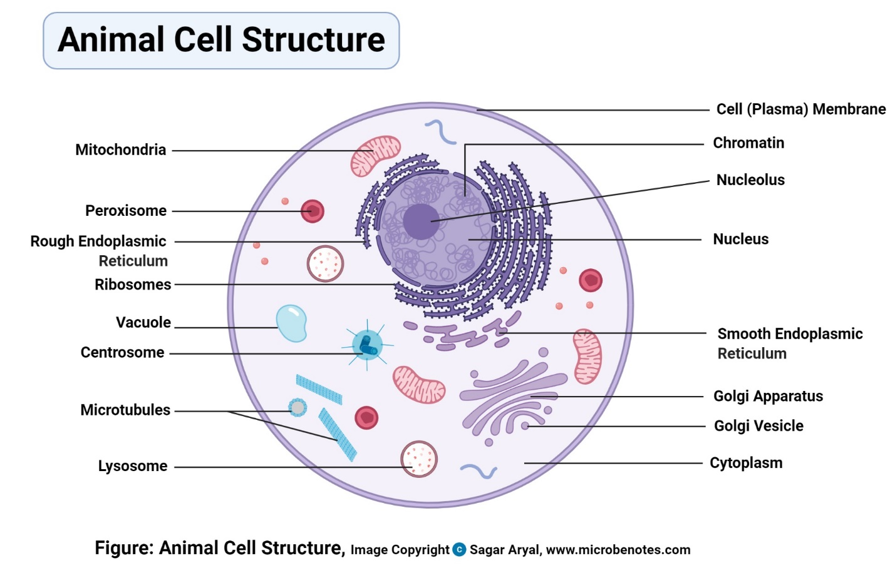
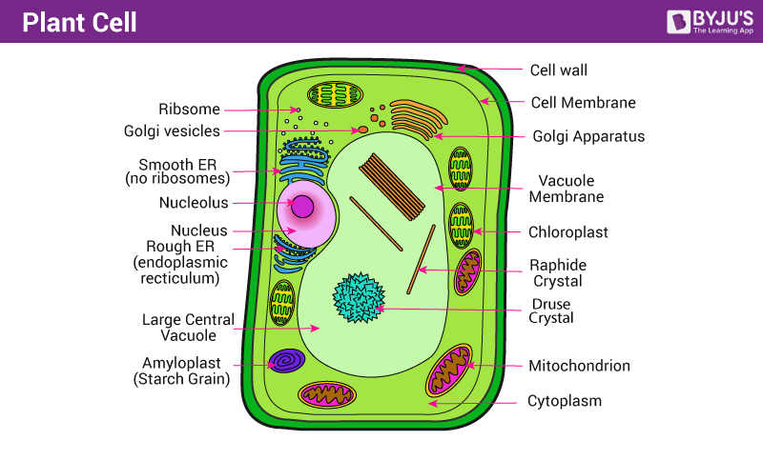
PARTS OF PLANT AND ANIMALS CELLS.
The living cells of plant and animals consists of many parts but the following three parts are the main parts or distinct parts. 1. Nucleus, 2. Cytoplasm 3. Cell membrane /plasma membrane
FUNCTIONS OF THE PARTS OF A CELL.
- Organelles; An organelle is a structure within a cell, bounded by a membrane and having a particular function in the cell.
- Cell wall; it forms a framework, which protects, support and gives shape to the cell. It is found in plants cells only and made up of cellulose, which is non-living material. Fungi and bacteria also have cell walls. In bacteria the cell wall is made up of proteins and fats while that of fungi consist of chitin.
- Cell membrane/ plasma membrane; it is a thin flexible membrane made up of fatty material and proteins with pores and holes which encloses the cell body thereby making the cell a whole or complete. It is a semi-permeable and thus control the movement of materials in and out of the cell.
- Protoplasm; the protoplasm forms the cell body and it consist of the cytoplasm and the nucleus.
- Cytoplasm; this is a transparent, watery substance containing various organelles and surrounding the nucleus. It is the site for most chemical reactions. It helps in the intra cellular distribution of molecules, enzymes and nutrients within the cells. Cytoplasm also helps in breaking down glucose. It helps in the exchange of materials between different cell organelles.
- Nucleus; it is oval in space and surrounded by a double membrane. The nucleus is the main organelle of the cell and it embedded in the cytoplasm. The nucleus has the following functions
- It controls all the activities of the cell and is the centre for the formation of mRNA.
- It contains threadlike structure chromosomes, which are genetic material of the cell.
- It contains DNA, which carries the instruction for the synthesis of protein.
- It controls cell divisions.
- It plays an important role in the manufacture of ribosomes by its nucleus.
- Vacuole; it is a large membrane sac filled with fluid. It is bounded by a single membrane and forms about 80% of the cytoplasm. Vacuoles are found in plants and animal cells but are much more prominent in plant cells.
FUNCTIONS;
- It is a temporary storage of food substances and waste metabolic products.
- Contractile vacuoles are for excretion and osmo-regulation.
- It provides turgidity in plant cell.
- Toxic substances in plant vacuoles help protect a plant from herbivores.
- Mitochondrion; these are sausage or spindle shaped structures surrounded by double membranes. It is the site for cellular respiration to produce energy; therefore, the mitochondrion is referred to as a powerhouse. Mitochondria are abundant in tissues or cells whose activities involved the expenditure of energy e.g. muscle cell, sperm cell and nerve cell. The main function is to produce energy or ATP (adenosine triphosphate) from cellular respiration.
- Chloroplast; it contains chlorophyll, which enables green plants to trap solar energy to manufacture food by the process of photosynthesis. They are found in only green plants. Large, egg-shaped or disc-shaped organelles bound by double membrane.
- Chromosomes; it carries heredity materials in form of DNA, which determines the organism’s and inheritances.
- Endoplasmic reticulum; it is a system of membranes lined sacs that form channels through the cytoplasm and continues with the nuclear membrane. There are two types; Rough and smooth E.R. The rough E.R have two ribosomes encrusted or found on the surface. The E.R works closely with the Golgi apparatus and ribosomes and has the following functions;
- Rough E.R is involved in protein synthesis; smooth E.R synthesizes liquids that occur in the membranes.
- It gives mechanical support to the cytoplasm.
- It divides the cytoplasm into small compartments.
- It provides a large surface area inside the cells for various physiological activities.
- It packs/ transports proteins and liquids from one part of the cell to another. In the testes, E.R produces testosterone and, in the liver, it helps detoxify drugs.
- Ribosomes; they are very small organelles freely found in the cytoplasm/ attached to the E.R or mitochondrion. It is composed of RNA (ribonucleic acid) and protein, and is the site for protein synthesis in the cells.
- Lysosomes; it is involved in autophagy e.g. worn-out organelles and autolysis (self-destruction of a cell) as part of cell replacement, maintenance, growth and repair tissues. It contains enzymes, which are involved in the cellular defense against attack by bacteria, viruses and toxic substances. It aids in digestion of food materials in vacuoles during growth and repair.
- Centriole; it is responsible for the formation of a piece spindle in cell division. They aid in the formation of cilia and flagella. They are small rod-like structures which lie in pairs in the cytoplasm near the nuclear membrane of most animal cells.
- Golgi body; it is found in the cytoplasm of all eukaryotes but absent in those bacteria. It is involved in packaging and secretion of proteins/ carbohydrates. It produces cell membranes.

SIMILARITIES BETWEEN PLANT AND ANIMAL CELLS
- Both have nucleus
- Both have cytoplasm
- Both have vacuoles
- Cell membranes are present in both
- Mitochondrion is present in both

DIFFERENCES BETWEEN PLANT AND ANIMAL CELL
PLANTS CELL | ANIMAL CELL
Have cell wall | Have no cell wall
Chloroplasts are present | Lack chloroplast
Have large but few permanent vacuoles | Have small/tiny numerous temporary vacuoles
Cells have fixed and rigid shapes | Cells have irregular and flexible shapes
Lack centrioles | Centrioles are present
Protoplasm is less dense | Protoplasm is denser
Carbohydrates are store as starch | Carbohydrates are store has glycogen.

SPECIALISED CELLS
They are cells that have been modified is shape, size and content to perform a particular or specific function in a multicellular organism. They are made to exhibit division of labour in multicellular organisms that is they carry specific function in an organism. Examples of the specialized cells are; leaf palisade cell, root trip cell, leaf epidermal cell, lymphocytes and phagocytes.
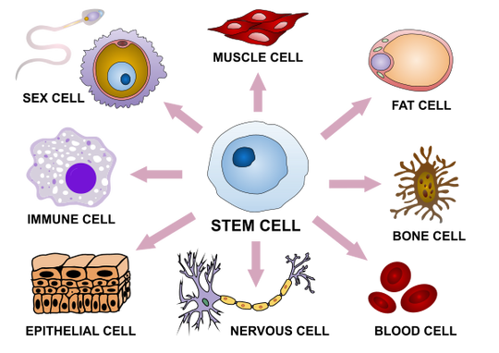
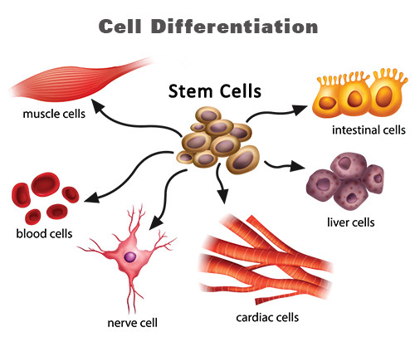
- The sperm cell; is designed to fertilize eggs.
- Ovum(egg) cell; designed to be fertilized by a sperm.
- Palisade cell; is designed for photosynthesis. They are found beneath the upper epidermis of the leaf.
- White blood cell; they are blood cells adapted for destroying harmful micro-organism that include the body.
- Root hair cell; designed for absorption of water and mineral salt.
- Red blood cell; they have the ability to carry oxygen to other body cell via the blood stream.
- Muscle cell; they have the ability to contact and relax to effect movement.
- Nerve cell; they conduct electrical impulses for sensory organs to the central nervous system.

THE LEVELS OF ORGANIZATION IN MULTICELLULAR ORANISM.
Cells → tissues →organs →organs system→ organism
- Cells; the basic structural and functional unit of an organism.
- Tissue; cells that are similar in shape size which perform the same functions. E.g. mesophyll, epidermis, muscular, skeletal and epithelial tissues.
- Organ; this is group of different tissue that perform specific functions. E.g. leaves, branches, flowers, stomach, heart, liver etc.
- Organ system; is a group of several organs whose functions are co-ordinated to produce effective action in a living organism. E.g. shoot system, nervous system, digestive system.
- Organism; difference organs system working together for organism as a whole.
NB; The complexity of the structure increasing as we move from cells to organism and the complexity decreasing as we move from organism to cells.
CELL DIVISION
Cells in the body can be divided into two, body cell/somatic cells and sex cell/gametes. Three main events takes place when a cell divides. These are division of the nucleus, divisions of the cytoplasm and cell separation. There are two types of cell division namely mitosis and meiosis.
MITOSIS; This is the division of a cell to form two daughter cells, one nucleus divides and produces two daughter cells each of which contains the same number of chromosomes of the mother cells. This takes place in the body/ somatic cell when cell divides during growth and development.
Cytokinesis ; this is referred to as cytoplasm division. In the cell of animals a constriction is formed along the equator. The constriction deepens and cuts the cell into two new daughter cells. In plant cell, a cell plate is formed along the equator first as scattered droplets. The droplets come together(coalesce) and fuse with the cell wall. Further deposition of materials on the cell plate forms a new wall, separating into two new(daughters)cell.
STAGES OF MITOSIS
- Interphase; at this stage the long chromosome threads of the nucleus become paired threads which are joined at a centromere. The chromosomes become visible under light microscope due to the condensed and shortened nature. Centrioles which are paired organelles located in the cytoplasm closer to the nuclear envelope replicate(divide). The two pairs then begin to move toward opposite ends/poles of the cell.
- Prophase; the centrioles reach the opposite poles of the cell and asters (very small tubules) appear, radiating from the centrioles. The nucleus disappears and the nuclear membrane cannot be seen due to some changes that takes place.
- Metaphase; spindles are formed and chromosomes become very thick and short. The chromosomes are arranged on the equator of the cell, attached to the spindle fibres by the centromeres.
- Anaphase; each centromere splits into two. The spindle fibres drag sister chromatids which are then separated, to opposite poles of the cell.
- Early telophase; chromatids reach the poles of the cell and become chromosomes again by uncoiling and at this stage cannot be clearly seen under the light microscope. Nuclear membranes begin to reform and cytoplasm begins to divide.

SIGNIFICANCE OF MITOSIS
- It increases the number of cells in an organism, and is used therefore for growth in multicellular organisms.
- Mitosis produces cells which are identical to the parent cell therefore ensure that there are genetically no different cells introduced.
- It is the basis of asexual reproduction.
MEIOSIS; This is a reduction division of a cell, which occurs within reproductive organs. A complete meiotic division of one cell gives rise to four gametes, each having half the chromosomes number of the parent cell. Thus, it is a special kind of cell division which takes place only during the formation of gametes. E.g., sperm, ova and pollen grains. In man, meiosis takes place in the ovaries and testes. Meiosis has 2 parts; MEIOSIS I AND II.
MEIOSIS I
There are four stages;
- Prophase I; the chromosomes become shortened and can be seen under the light microscope. Homologous chromosomes pair up and come very close to each other in a process called synapsis. The pair referred to as a bivalent. Portion of the two chromosomes forming a pair become joined at some points. The points are called chiasmata(singular, chiasma). They break at the chiasmata and the chromosomes exchange portions of their lengths. This, therefore, results in the movement of genes from one chromosome to the other. The process is referred to as crossing over.
- Metaphase I; the bivalents which may be held together by the chiasma move to the equator of the cell positioned on the spindle fibres.
- Anaphase I; the homologous chromosomes are pulled toward opposite poles.
- Telophase; chromosomes reach the poles with homologous chromosomes separated. Nuclear membrane forms around the chromosomes at the poles. Cleavage of the cell takes place to produce two cells from one present cell.

MEIOSIS II
- Interphase II; represent testing stage yet there is accumulation of materials for the next stage of the process. It does not involve DNA replication.
- Prophase II; the nuclear envelop disintegrates and spindle fibres from chromatin becomes short and thick.
- Metaphase II; chromosomes arrange along the equator of the cell.
- Anaphase II; sister chromatids separate and are pulled to opposite poles of the cell.
- Telophase II; nuclear membrane forms around the daughter nuclei. chromosomes become long and uncoiled. They are visible. Spindle fibres disappear and the centrioles replicate. Cytokinesis divides the cell.
EFFECTS OF MEIOSIS
It results in the formation of daughter cell which has the following characteristics;
- Half the number of chromosomes found in the parent cell.
- Different combination of chromosomes from those in the parent cell.
- The reduction in chromosomes number is necessary because the fertilized ovum contains chromosomes from both the male and female gametes.
HOW MEIOSIS BRINGS ABOUT VARIATION IN ORGANISMS
The separation of each pair of alleles of homologous chromosomes during meiosis in the process of gametes formation, and the subsequent recombination during fertilization, a random process that bring alleles from parents together in different combinations.
Secondly, due to crossing over that occurs during meiosis, new combinations of genes are formed in the gamates, which can as well lead to variation.
SIGNIFICANCE OF MEIOSIS
- It ensures continuity of species.
- It can lead to genetic variation.
- It ensures that the chromosomes number of the species, is kept constant in the subsequent generations.

DIFFERNCES BETWEEN MITOSIS AND MEIOSIS
MITOSIS | MEIOSIS
1.occurs in somatic cells | 1.occurs in reproductive(germ)cells
2.chromosomes number is maintained | 2.chromosomes number is halved.
3.No pairing of chromosomes in mitosis | 3.Pairing occurs
4.No crossing over | 4.Crossing over occurs
5.Chromatids separate | 5.chromosomes separate
6.Cell division occurs ones | 6.Cell division occurs twice
7.Two daughter cells formed | 7.Four daughter cells formed

