ATOMIC STRUCTURE.
ATOMIC NUMBER, MASS NUMBER, ISOTOPES AND RELATIVE ATOMIC MASS
The nucleus: The nucleus is at the centre of the atom and contains the proton and neutrons. Protons and neutrons are collectively known as nucleons. Virtually, all the mass of the atom is concentrated in the nucleus, because the electrons weigh so littles.
Atomic number(z): This is the number of protons in the nucleus of an atom. In an atom, the number of protons is equal to the number of electrons. The atomic number is also given a more descriptive name of proton number.
Mass number(A): is the sum of the number of protons and neutrons in the nucleus of an atom. Number of protons + Number of neutrons = mass number of the atom. The mass number is also called the nucleon number. This information can be given simply as illustration below;
A particular element, X can be depicted as………... where the superscript A is the nucleon number and the subscript is z, which is the atomic number. Mathematically, A = Z+N
Example fluorine atom, ¹⁹₉F (how many protons, and neutrons has this atom got?) Atomic number (z)=9; mass number(A)=19 A=Z+N A-Z=N 19-9=10 Neutrons.

DIFFERENCES BETWEENPROTONS AND ELECTRONS.

PROTONS | ELECTRONS
Have positive charge | have negative charges
Protons reside inside nucleus | Electrons reside outside the nucleus
Protons do not take part in bonding | Electrons are used in bonding
the relative mass is 1 unit | the mass is negligible

Worked examples
- The atomic number of an atom Y is 17 and the mass number is 35. Indicate the number of (i)protons ( ii) electrons (iii) neutrons in the atom.
SOLUTION;
(i)The number of protons is 17 (because the number of protons is equal to the same as the atomic number.
(ii)The number of the electrons is 17 (because the number of protons is equal to the number of electrons in a neutral atom.
(iii)The number of Neutron(N)=mass number(A)- Atomic number (2)
N=A-Z
N=35-17=18

- An atom has 17 protons and 11 neutrons in its nucleus. Find the ff. for the atom (i) mass number (28) (ii)number of electrons (17).

ISOTOPES: are defined as atoms of the same element having different mass numbers due to differences in number of the neutrons of the atoms. OR atom of the same element with the same number of protons but different number of neutrons.
Examples; chlorine exists naturally with 2 isotopes namely chlorine -35 or ³⁵₁₇ Cl and chlorine -37 ³⁷₁₇Cl.
In ³⁵₁₇Cl atom there are 17 protons and 18 neutrons so that the atom has a mass number of 35. In ³⁷₁₇Cl atom, there are 17 protons and 20 neutrons so that this atom has a mass number of 37. Other common elements which have isotopes are:
Oxygen [¹⁶₈O, ¹⁷₈O, ¹⁸₈O]
Carbon [¹²₆C, ¹³₆C, ¹⁴₆C]
Hydrogen [¹₁H, ²₁H ,³₁H]
Magnesium [²⁴₁₂Mg, ²⁵₁₂Mg, ²⁶₁₂Mg]

THE ELECTRONIC CONFIGURATION.
The arrangement of electrons in the shells of an atom is called electronic configuration. A shell is the path through which an electron moves or energy level of electrons. Every nucleus has shell around it and every shell has a name assigned to it. The shell with the lowest energies is nearest to the nucleus and those with largest energy are further away from the nucleus.
The shell and their capacities
- K shell is the first shell. It can take a maximum of 2 electrons.
- L shell is the second shell. It can take maximum of 8 electrons.
- M shell is the third shell can take a maximum of 18 electrons.
For stability, the M shell can contain a maximum of 8 electrons instead of 18. This exception is according to a rule called octet rule.
- N shell, is the fourth shell and takes a maximum of 32 electrons.

Configuration of the first 20 elements of the periodic table.
Element/symbol | Atomic number | Mass number | No. of P N E | Electronic configuration
Hydrogen, H | 1 | 1 | 1 0 1 | 1
Helium, He | 2 | 4 | 2 2 2 | 2
Lithium, Li | 3 | 7 | 3 4 3 | 2, 1
Beryllium, Be | 4 | 9 | 4 5 4 | 2, 2
Boron, B | 5 | 11 | 5 6 5 | 2, 3
Carbon, C | 6 | 12 | 6 6 6 | 2, 4
Nitrogen, N | 7 | 14 | 7 7 7 | 2, 5
Oxygen, O | 8 | 16 | 8 8 8 | 2, 6
Fluorine. F | 9 | 19 | 9 10 9 | 2, 7
Neon, Ne | 10 | 20 | 10 10 10 | 2, 8
Sodium, Na | 11 | 23 | 11 12 11 | 2, 8, 1
Magnesium, Mg | 12 | 24 | 12 12 12 | 2, 8, 2
Aluminum, AL | 13 | 27 | 13 14 13 | 2, 8, 3
Silicon, Si | 14 | 28 | 14 14 14 | 2, 8, 4
Phosphorus, P | 15 | 31 | 15 16 15 | 2, 8, 5
Sulphur, S | 16 | 32 | 16 16 16 | 2, 8, 6
Chlorine, Cl | 17 | 35 | 17 18 17 | 2, 8,7
Argon, Ar | 18 | 40 | 18 22 18 | 2, 8, 8
Potassium, K | 19 | 39 | 19 20 19 | 2, 8, 1
Calcium, Ca | 20 | 40 | 20 20 20 | 2, 8, 2

Relative Atomic Mass (Ar)
Is ratio of the average mass of atoms of an element (from a single given sample or source) to 1/12 of the mass of an atom carbon – 12 (known as the unified atomic mass unit). It is also known as atomic weight. OR Ar of an element is the number of times an atom is heavier than one twelfth the mass of one atom of carbon-12 .Thus, Relative atomic mass (Ar) = $\frac{mass of one atom of an element}{\frac{1}{12}of the mass of the carbon-12 atom}$
Owing to the existence of isotopes, atomic masses are usually not whole numbers. Actually, the atomic mass of an element is the weighted average of the atomic masses of all isotopes of the element. Hence, we may define relative atomic mass (Ar) of an element as the weighted average mass of the various isotopes of an element compared with one twelfth the mass of an atom of carbon-12 isotopes.
Some elements have relative masses which are whole numbers. Eg; Ar of oxygen is 16.0, AL 27.0. The Ar of these two elements are the same as their mass numbers.

Illustration
Carbon has 2 main isotopes, carbon 13 ${}_{6}^{13}C$ and carbon 12 ${}_{6}^{12}C$. Their relative abundance are 11.11% and 98.89% R.P.T Hence, Ar of carbon s expressed as
$\frac{13×1.11}{100}$ × $\frac{12×98.89}{100}$ = 12.01
Chlorine has 2 isotopes, chlorine – 35 ${}_{17}^{35}C$ and chlorine-37 ${}_{17}^{35}{Cl}$. Hence, Ar = $\frac{35×3}{4}$ + $\frac{37×1}{4}$ =$\frac{142}{4}$ = 35.5
NB; The Ar mass of an element is a pure number and it does not have a unit.
MOLE, MOLAR MASS AND FORMULA MASS.
The mole concept.
Mole as a quantity. The mole is defined as the quantity of given substance that contains as ֒many elementary entities as there are atoms n exactly 12g of carbon – 12 isotopes.
Mole as a unit; is a unit that is used to describe a certain quantity of particles. The mole = 6.02 × ${10}^{23}$ particles or entities. The term particles refer to either atoms, protons, electrons, ions, molecules or formula unit. The number 6.02 × ${10}^{23}$ is called Avogadro’s constant or Avogadro’s number( $N_{A}$ or L).
MOLAR MASS(M): The mass of one mole of a substance is the molar mass. The unit of molar mass is g/mol.
Eg; 1 mole of carbon has a mass of 12g, hence the molar mass carbon is 12g/mol.
Eg; calculate the molar mass of
i.H₂SO₄ ii. NaCl iii. CuSO₄ iv. C₁₂H₂₂O₁₁ v. Ammonia (NH₃)
Relative atomic masses [H=1, S=32, O=16, Na=23, Cl=35.5, Cu=63, C=12, N=14]
- H₂SO₄= (1×2) +(32×1) +(16×4)
= 2+32+64= 98g/mol

Formular mass; defined as the mass of 1 mole of a formula unit, especially of ionic compound.
Eg;
Formular mass of KNO₃= (39×1) +(1×14) +(3×16) = 101g
؞ This means that 1 mole of KNO₃ has a mass of 101g.
Formular mass of CaSO₄ = (1×40) + (1×32) + (4×16) = 136g
This means 1mole of CaSO₄ has a mass of 136g or the mass of 1mole of CaSO₄ = 136g
Relation between Grains and Mole.
Mathematically, ${n=}_{M}^{m}$
Where, n= amount of substance
m = mass
M = molar mass
Eg1, calculate the mass of 0.5 mole of ion [Ar of Fe = 56.0]
n= 0.5
M = 56.0
But ${n=}_{M}^{m}$
m = n×M = 0.5 mol × 56g/mol = 28g
2. How many moles are there in 50g 0f NaOH? (1.25mol)
[Na = 23, O = 16, H=13
PREPARATION OF SOLUTIONS OF GIVEN CONCENTRATONS.
Solution; is a homogenous mixture of 2 or more substances. A solution contains a solute and solvent.
Solvent; is the substance of the solution that dissolves the other component. It is often present in greater amount.
Solute; is the substance of the solution that is being dissolved in the solvent. It is generally in small amount.
Eg; brass, aqueous ethanoic acid solution, Air.
CONCENTRATION OF SOLUTION.
Concentration expresses the quantity of solute in a given quantity of solvent or solution. There are a number of ways to express the relative amounts of solute and solvent in solution. These are; Molarity/amount of substance concentration, Mass concentration, percent composition (by mass), parts per million.
MOLARITY; is the amount of solute in exactly one litre of a solution. The symbol of molarity is “C”. The unit is mol/dm³ or ‘M’.
Molarity(C)= $\frac{amount of solute(n)}{volume of solute is litres({dm}^{3})(V)}$
Eg1; what is the concentration of a solution prepared by dissolving 6.0g of NaCl to make 500cm³ of solution
C= $\frac{n}{v}$
n= $\frac{m}{M}$ = $\frac{6.0g}{58.5g/mol}$ = 0.103mol
= c = $\frac{0.103mol}{0.5dm3 }$ = 0.206mol/dm³
2. What is the mass of NaOH contained in 1dm³ of 0.2M of NaOH. solution [Na= 23, 0= 16, H=1]
ANSWER- 8g
3. What is the volume of 0.5mol HCL solution with a concentration of 2M?
ANSWER - V= 0.25dm³.

Mass concentration; Mass concentration of a solution is expressed as the mass of a solute in grams(g) per unit volume (in dm³) of a solution.
Mass concentration, P = $\frac{moles of solute(n)}{volume of solution in litres(v)}$
= $\frac{g}{{dm}^{3}}$
E.g.; If 100g of sucrose is dissolved in 100dm³ of solution, the mass concentration of the solution is given by
Mass concentration, p, = $\frac{moles of solute}{volume of solution}$ = $\frac{100g}{100{dm}^{3}}$
Percentage by mass; This is considered in 2 ways;
- Parts of solute per 100 parts of solution
- Fraction of a solute in solution multiplied by 100.
Percentage by mass = $\frac{moles of solute}{volume of solution}$ × 100%
Eg1; If 100g of salt is present in 400g of solution, then the conc. of the solution is expressed by
C = = $\frac{moles of solute}{volume of solution}$ × 100% = = $\frac{100g}{400g}$ × 100%
2. A solution is prepared by dissolving 50g of glucose in 450g of H₂0. Cal the conc. of the solution
ANSWER- 10%
Concentration of a solution in parts per Million(ppm); The concentration of a solution can be expressed in terms of parts per million(ppm). The conc. is parts per million is used when the solution is highly diluted.
PREPARATION OF A STANDARD SOLUTION.
A standard solution is a solution whose conc. is accurately known
m = c x M x V
Steps involved in preparation standard solutions
- Calculate the molar mass of the substance whose solution you want to prepare.
- Work out the mass of the substance whose standard solution you need to prepare.
- Weigh the calculated mass on the balance.
- Transfer the solution into the required standard volumetric flask.
- Rinse the beaker with enough distilled water and add to the flask and its content.
- Top it up with distilled water to the mark.
- Insert the stopper and shake it well to obtain a uniform solution.
- Label the solution you have prepared.
DILUTION OF SOLUTION.
To dilute a solution means to add more solvent without the addition of more solute.
The rules of solute before dilution = moles of solute after dilution
^{n} concentration of solution = ^{n} dilution of solution
but, n = c x v
c₁ v₁ = c₂ v₂
examples,
- 53.4cm³ of a 1.50M solution of conc. HCL is on hand, but you need some 0.800M solution. How many mL of 0.800M can you make?
Solution
Using the dilution equation C₁ V₁ = C₂ V₂
1.50mol/dm³ x 53.4cm³ = 0.800mol/dm³
- 100.0cm³ of 2.500mol/dm³ KBr solution is on hand. You need 0.5500mol/dm³. What is the find volume of solution which results? (454.5cm³)

IMPORTANCE AND APPLICATION OF DILUTION.
- Dilution is applied in medicine to reduce the concentration of microscopic organism or cells in a sample.
- It is applied to prepare medicine of accurate concentrations.
- Concentrated drinks like fruit drinks are also diluted before they can be drunk.
- In our homes, antiseptics, disinfectants and some detergents are diluted befor they can be used.
IONIC AND COVALENT COMPOUNDS.
A chemical compound is formed by chemical combination of two or more atoms of elements. Generally, these are two types of compounds. These are, ionic or electrovalent compounds and covalent compounds.
Ionic compounds; these are compounds formed by the attraction of positive ions (cations ) and negative ions(anions). There is electrostatic force of attraction between the cations and anions that hold them together. This electrostatic force of attraction between the cations and anions is called ionic bond or electrovalent bond.
In ionic bonding, electrons are completely transferred from one atom to another. In the process, atoms either loss or gain negatively charged electrons. The reacting atom forms ions. The oppositely charged ions are attracted by each other by electrostatic forces, which are the basis of the ionic compound.
Example, during the reaction of sodium with chlorine; the process occur;
Sodium has electrons with only one electrons in its outer most shell, so it loses this electron to form Na⁺ ion. However, Cl has 17 electrons but only 7 electrons in its outermost shell. So Cl accepts the electrons lost from Na to become Cl⁻. In this way, both Na⁺ and Cl⁻ will have fully filled outer most shells but since they are oppositely charged, they attract each other to form NaCl. After the reaction has taken place, the charged Na⁺ and Cl⁻ ions are held together by electrostatic forces, thus forming an ionic bond.
Examples of ionic compounds; sodium chloride(NaCl), magnesium oxide(mgO), sodium oxide(Na₂O), magnesium chloride (mgCl₂), calc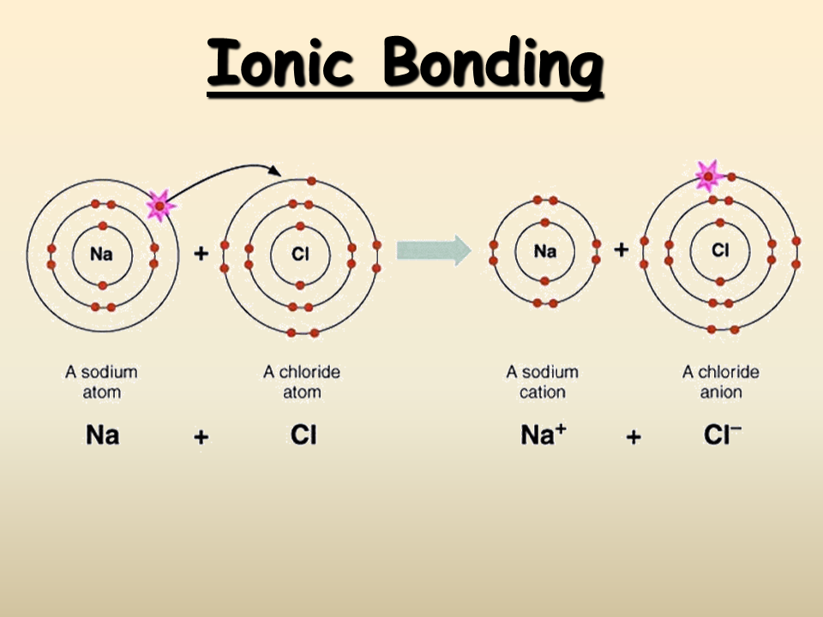ium chloride(CaCl₂), lithium fluoride(LiF)

Properties of ionic compounds
- Ionic compounds form crystals.
- Ionic compounds have high melting points and high boiling points.
- Ionic compounds are hard and brittle.
- Ionic compounds conduct electricity when dissolved in water of in molten state.
- Ionic compounds dissolve in polar solvents such as water.
- Ionic compounds are generally not inflammable compounds.
COVALENT COMPOUNDS; this type of compound is formed when two or more atoms share paired electrons to attain a noble gas structure.
As opposed to ionic bonding in which there is complete transfer of electrons, covalent bonding occurs when two or more electrons share pairs of electrons. Covalent bonding occurs when the atoms in the compound have similar tendency for gaining electrons. This commonly occurs when two non-metals bond together.
A good example of covalent bond is that which occurs between two hydrogen atoms. Atoms of hydrogen (H) have one valence electron in their first electron shell. Since the capacity of this shell is two electrons, each hydrogen atom will “want” to pick up a second electron, in an effort to pick up a second electron. Hydrogen atoms will react with other hydrogen(H)atoms to form Hydrogen molecule(H₂). The hydrogen molecule is a combination of same atoms of elements, the atoms will share each other’s single electrons, forming single covalent bond. In this way, both atoms share the stability of a full valence shell.
NOTE:
- Covalent bonds can be single, double or triple bonds, depending on the number of electrons pairs share between the atoms.
- In the formation of covalent bonds, only the valence shell with the valence electrons can be shown because the core electrons are not used in bonding.
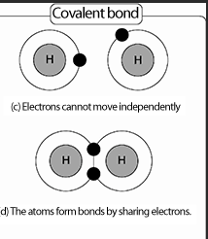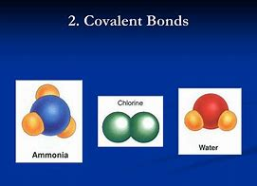
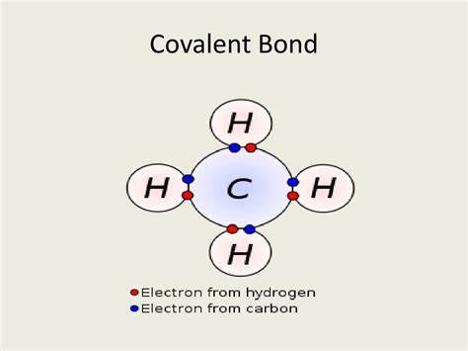
Properties of covalent compounds.
- Most covalent compounds have relative low melting and boiling points.
- Covalent compounds tend to be soft and relative flexible.
- When dissolved in water, covalent compounds do not conduct electricity
- Many covalent compounds do not dissolve well in water.eg. sugar and ethanol.
Examples of covalent molecules and compounds.
Chlorine (Cl₂), oxygen(O₂), Hydrogen(H₂), Hydrogen chloride (HCl), water (H₂O), carbon dioxide (CO₂), Ammonia (NH₃).
IUPAC NOMENCLATURE.
IUPAC nomenclature is a system of naming chemical substances or compounds according to the rules of the international union of pure and applied chemistry. IUPAC nomenclature is used for naming both inorganic and organic substances. Before you can give an IUPAC name of chemical substances or compounds, you need to know the oxidation or state of elements.
Oxidation number; is the actual charge or the assigned charges of atom in a free or combined state based upon asset of rules.
Set of rules for assigning oxidation number.
- The oxidation number of a free element is always 0. Eg. The atoms in He, N₂, Na, C and O₂ have oxidation numbers of 0.
- The oxidation number of a simple ion (monoatomic ion) equals the charge of the ion.eg. the oxidation number of Na⁺ is +1, the oxidation number of N³⁻ is -3.
- The usual oxidation number of hydrogen is +1 in non-metal hydride eg; HCl
- The oxidation number of hydrogen is +1 in all compounds except in metallic hydrides such as hydrogen in CaH₂, NaH where it is -1.
- The oxidation number of oxygen in most compounds is usually -2.
- The oxidation number of oxygen -2 in all compounds except peroxides such as the oxygen in H₂O₂.
- The sum of the oxidation numbers of all the atoms in a neutral compound s 0.
- The sum of the oxidation numbers in a polyatomic ion is equal to the charge of the ion.
- For example, the sum of the oxidation numbers for SO₄²⁻ is -2.

Example . determine the oxidation state of the ff.
- KMnO₄
1 + x + 4(-2) =0
x + 1 – 8 = 0
x = 8 – 1
x = +7

- Cr₂O₇²⁻
2x + 7(-2) = -2
2x – 14 = -2
2x = -2 + 14
2x = 12
X = +6
Therefore, Each chromium in the ion has an oxidation state of +6.

WORKED EXAMPLES
Find the oxidation state of the ff ions.
- F⁻ = - 1 2. Mg₂⁺= +2 3. Al³⁺= +3 4. Mn⁵⁺ = +5 5. Mn⁷⁺= +7
6. Fe²⁺ = +2 8. O²⁻ = - 2

Naming of inorganic compounds
Binary compounds; in naming binary compounds the electropositive element (the one that appears first) is named first. The oxidation state of the electropositive element is ignored if it is fixed. However, if it is variable, it must be indicated as a capital roman numeral in parenthesis.
The last letters of the second element is dropped and ‘ide’ is added to it to give a clear name .eg; chlorine and oxygen becomes chloride and oxide respectively.
EXAMPLES are;
NaCl = sodium chloride
KCl = potassium chloride
Co = carbon(ii)oxide or carbon monoxide
CO₂ = carbon(iv)oxide
Zncl₂ = zinc chloride
N₂O₅ = Nitrogen(v)oxide

OXOANIONS; are those polyatomic anions in which the central atoms is bonded to oxygen. There are large number of oxoanions, which takes it difficult to remember all of their names. Fortunately, there is a set of rules that makes this task much easier.
In naming oxoanions, the number of oxygen atoms is named using Greek prefixes eg;
- 1- Mono (but remains silent) eg HOCL = oxochlorate(i) acid not monochlorate (i) acid
- 2- Dioxo
- 3- Trioxo
- 4- Tetraoxo
- 5- Pentaoxo
- 6- Hexaoxo

The last letter of the name of the central element is replaced by ‘ate’ followed by its oxidation number in parenthesis. Ion is added to give the full name.
NO₃⁻ = trioxonitrate(v) ion
SO₄²⁻ = tetraoxosulphate(vi) ion
CO₃²⁻ = trioxocarbonate(iv) ion
PO₄³⁻ = tetraoxophosphate(v) ion
ClO₃⁻ = trioxochlorite(v) ion
NO₂⁻ = dioxonitrate(iv) ion
SO₃²⁻ = trioxosulphate(iv) ion
CLO₂⁻ = dioxochlorate(iii) ion
CLO⁻ = oxochlorate(I) ion
Examples; name the ff compounds
CaCO_{3,} Na₂CO₃, AL(NO₃)₃, PbCO₃, CUSO₄, Al₂(SO₃)₃, Li₂CO₃, KNO₃, KMnO₄
Solution
Compound | IUPAC NAME
CaCO₃ | Calcium trioxocarbonate(iv)
PbCO₃ | Lead(ii) trioxocarbonate(iv)
Li₂CO₃ | Lithium trioxocarbonate(iv)
Na₂CO₃ | Sodium trioxocarbonate(iv)
CUSO₄ | Copper(ii) tetraoxosulphate(vi)
KNO₃ | Potassium trioxonitrate(v)
AL(NO₃)₂ | Aluminium trioxonitrate(v)
Al₂(SO₃)₃ | Aluminium trioxosulphate(iv)
KMnO₄ | Potassium tetraoxomanganate(vii)

